Hotel Booking Management System
UML Design Documentation
Course: Software Engineering
Project Title: Hotel Booking Management System
Done by: ALEX GITHINJI E020-01-0883/2023
Kilavi Musyoki E020-01-0896/2023
Mutemi Purity E020-01-2356/2022

1. Introduction
This document presents the Unified Modeling Language (UML) diagrams developed for the Hotel Booking Management System as part of the System Design Phase of the Software Development Life Cycle (SDLC). UML is used to visually model system functionality, workflows, interactions, and structural design before implementation.
The Hotel Booking Management System is designed to allow customers to search for available hotel rooms, make reservations, and manage bookings online. Additionally, the system supports hotel administrators and staff in managing rooms, reservations, payments, and generating reports to support decision-making.
The UML diagrams included in this document are:
- Use Case Diagram
- Activity Diagram
- Sequence Diagram
- Class Diagram
Each diagram is explained in detail to demonstrate a clear understanding of system behavior and architecture.

2. Use Case Diagram
Purpose of the Diagram
The Use Case Diagram provides a high-level functional view of the Hotel Booking Management System. It illustrates how different actors interact with the system and identifies the major services the system provides.
This diagram helps stakeholders understand system scope, user responsibilities, and functional boundaries.

Actors Identified
- Customer: End user who searches for rooms, makes bookings, and manages reservations
- Hotel Staff: Personnel responsible for handling reservations and monitoring room availability
- Administrator: Manages system users, room data, and generates operational reports

Main Use Cases
- Register / Login
- Search Available Rooms
- Book Room
- Modify or Cancel Booking
- Make Payment
- Manage Rooms
- View Bookings
- Generate Reports

Diagram Explanation
The diagram shows customers initiating booking-related actions such as searching for rooms, making payments, and managing reservations. Hotel staff interact with the system to monitor bookings and availability, while administrators perform higher-level management tasks such as room configuration and report generation.
The system boundary clearly defines which actions occur inside the system, ensuring clarity between user actions and remember internal processing.
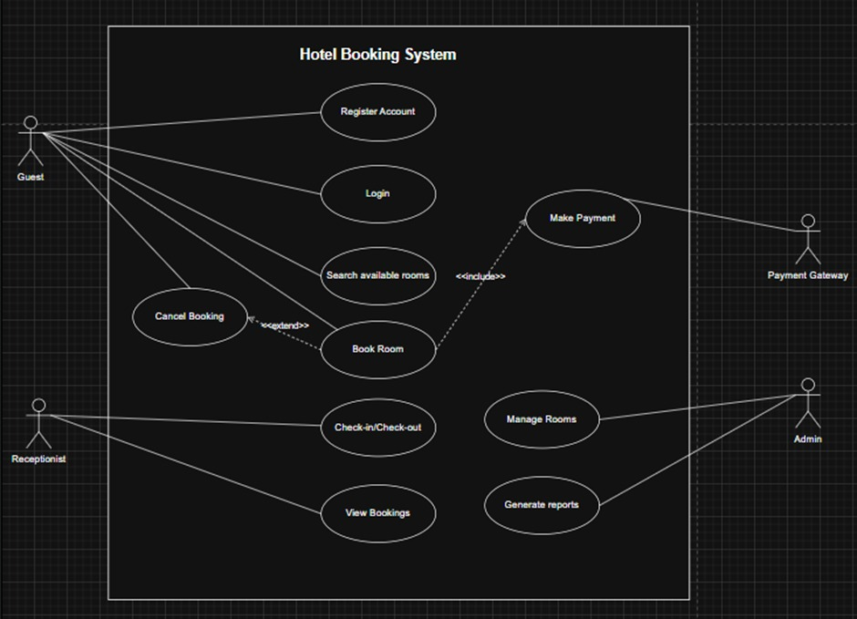

3. Activity Diagram
Purpose of the Diagram
The Activity Diagram models the dynamic workflow of a key business process within the system. It focuses on the sequence of activities, decision points, and flow control from start to end.

Process Modeled
Customer Booking a Hotel Room: This process was chosen because it is one of the most critical and complex workflows in the system.

Workflow Description
- The process begins when the customer initiates a room search
- The system checks room availability based on selected criteria
- A decision point determines whether rooms are available
  - If no rooms are available, the process ends
  - If rooms are available, the customer selects a room
- The customer proceeds to payment
- The system processes payment and confirms the booking
- A booking confirmation notification is sent
- The process terminates successfully
Swimlanes are used to separate responsibilities between the Customer, System, and Payment Service, clearly showing accountability.
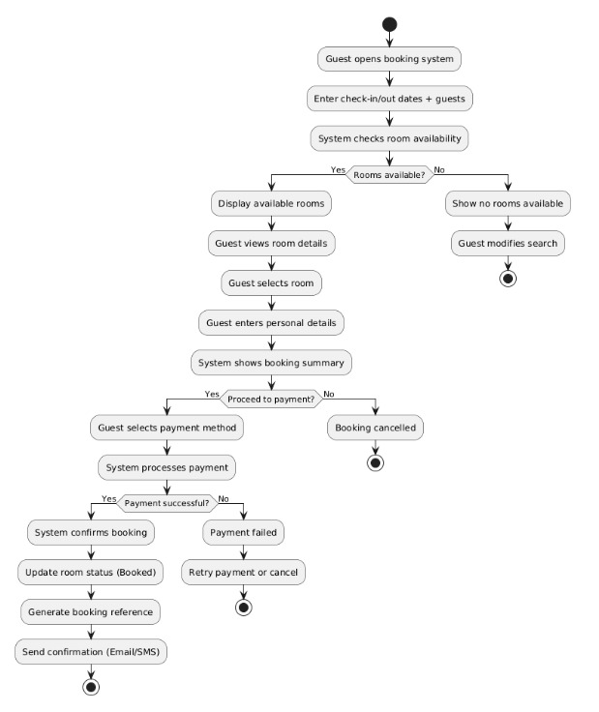
4. Sequence Diagram
Purpose of the Diagram
The Sequence Diagram illustrates interaction and message flow over time between actors and system components for a specific scenario. It emphasizes object communication and execution order.
Scenario Modeled
Booking a Hotel Room
Objects and Components Involved
- Customer
- User Interface
- Booking Controller / Service
- Database
- Payment Gateway

Interaction Explanation
The customer initiates the booking process through the user interface. The system queries the database to verify room availability. Once availability is confirmed, the system processes payment through the payment gateway. After successful payment, the booking details are stored in the database, and a confirmation is returned to the customer.
Activation lifelines show the period during which each object is active, while arrows represent synchronous method calls and responses.
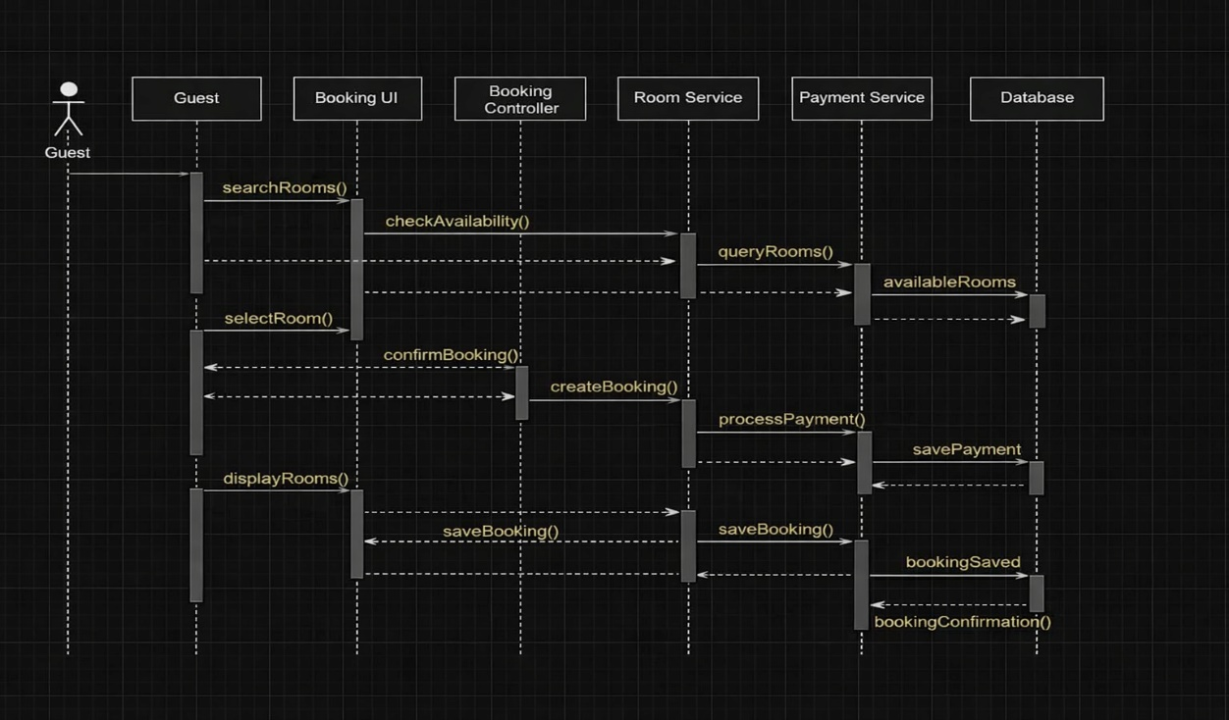

5. Class Diagram
Purpose of the Diagram
The Class Diagram provides a static structural view of the system. It identifies system classes, attributes, operations, and relationships that define how data and responsibilities are organized.
Identified Classes
- User
- Customer
- Admin
- Hotel
- Room
- Booking
- Payment
- Notification
- Report

Attributes and Methods
- User: userId, username, password, login()
- Room: roomId, roomType, price, availabilityStatus
- Booking: bookingId, bookingDate, status, confirmBooking()
- Payment: paymentId, amount, paymentStatus, processPayment()

Relationships
- A Customer can make multiple Bookings (1..*)
- A Room can be associated with many Bookings
- Each Booking has exactly one Payment
- An Admin manages Rooms and Reports
The diagram uses association, inheritance, and cardinality to accurately model real-world hotel operations.
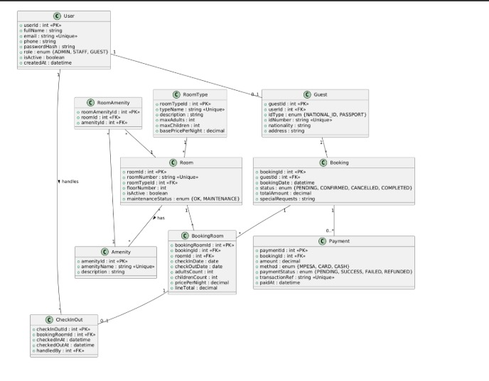

6. Overall System Design Justification
The combination of UML diagrams provides a complete system view:
- Use Case Diagram → What the system does
- Activity Diagram → How processes flow
- Sequence Diagram → How components interact
- Class Diagram → How data and structure are organized
This design ensures scalability, maintainability, and clarity before implementation.

7. Conclusion
The UML diagrams presented in this document effectively model the Hotel Booking Management System during the design phase of the SDLC. They provide a shared understanding among stakeholders and form a solid foundation for future system implementation and testing.

